**Topic: Plant Disease Classification App**

**Project Implementation Plan**

* **Modules –**

1. **Login/Registration:** This module will allow a user to login or either register themselves with a username, phone number and password. In case of login validation would be performed from the database before directing to the image scan screen. Whereas in case of sign up the details will be stored in the database for further validation.
2. **Image upload/scan:** Creating a module for scanning or uploading images from gallery and a dataset of pictures of diseased and healthy plant leaves under controlled conditions.
3. **Disease Detection:** Setting up data generators that will read pictures, convert them and feed them (with their labels) to our network and detect whether the given plant has disease or not.
4. **Treatment:** If a disease is detected, then on click of a button the treatment module will open up.

* **Technologies –**

**Software -**

* **Language:** Python, Java, SQL , XML
* **IDE:** PyCharm, Android Studio
* **Backend**: Real time Database(Firebase)
* Machine Learning
* TensorFlow Lite

**Google Colab** - For training data and testing data.

**Hardware-**

* 8GB RAM Laptop
* Windows 10
* Android Phone
* **Timeline –**

|  |  |  |  |
| --- | --- | --- | --- |
| **Start Date** | **Duration** | **End Date** | **Implementation** |
| 25/08/2020 | 18 days | 11/09/2020 | Collecting Data |
| 13/09/2020 | 4 days | 16/09/2020 | Building login and registration module |
| 18/09/2020 | 10 days | 27/09/2020 | Scan Image Module and Treatment Module |
| 30/09/2020 | 6 days | 05/10/2020 | Loading and labelling of data in Tensor Flow |
| 7/10/2020 | 20 days | 26/10/2020 | Working on Tensor Flow Model-Testing and Training |

* **Screenshots : (21/09/2020)**

1. **Welcome Page:**

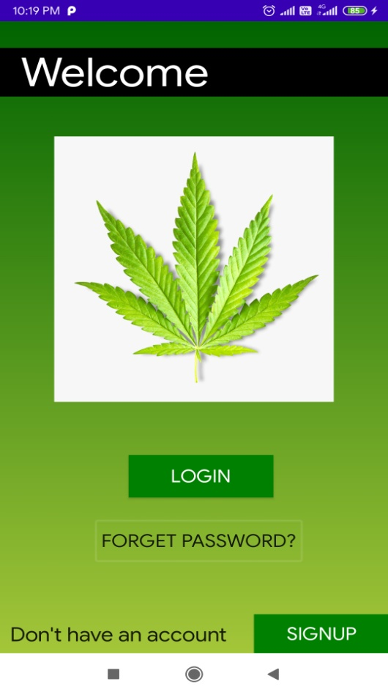

1. **Login Page:**

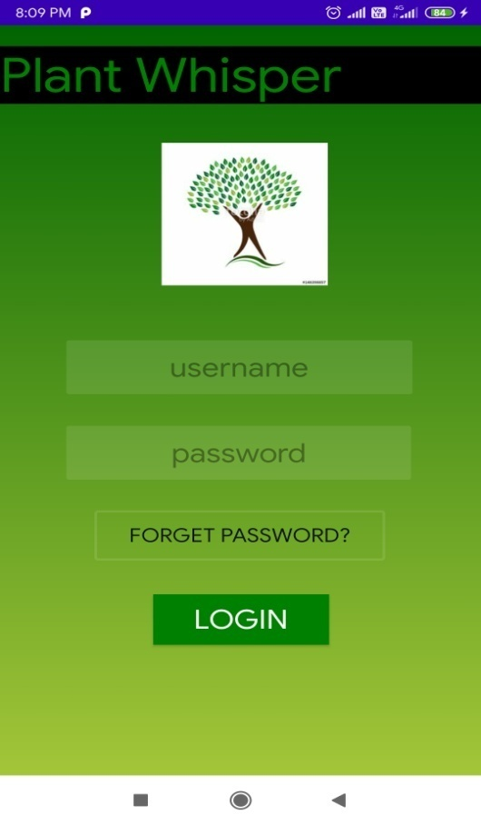

1. **Sign-up Page:**

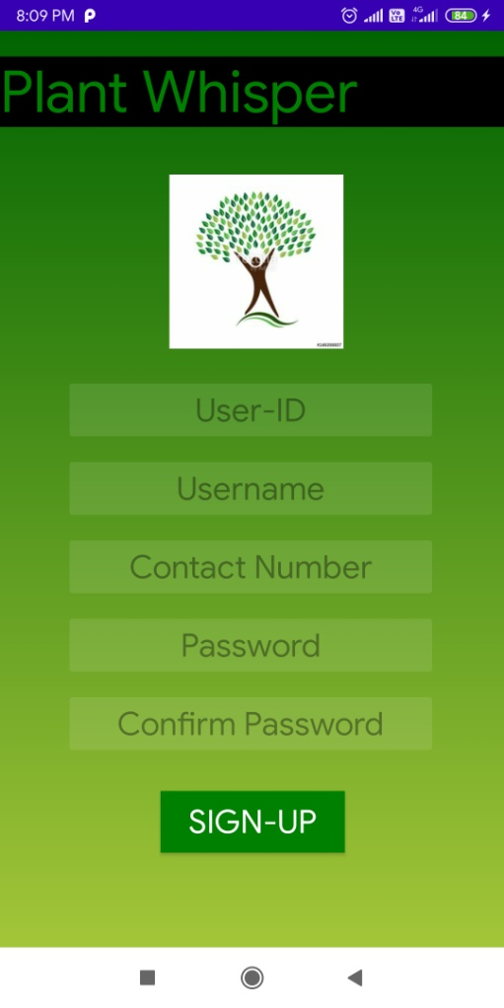

1. **Forget Password Page:**

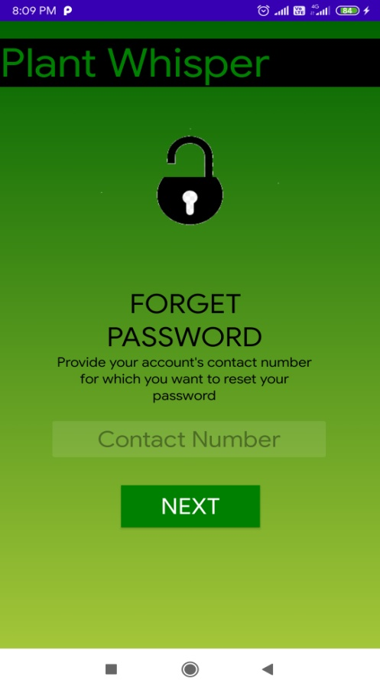

1. **Login Validation:**

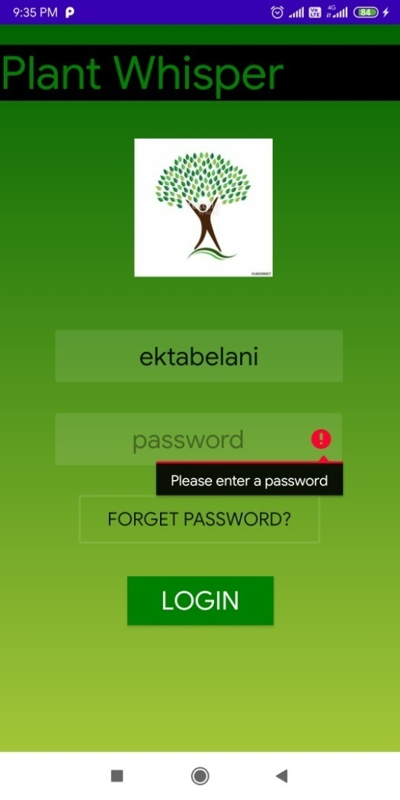

* **Work Done : (21/09/2020)**

1. Completed Login, Registration, Forget Password Module
2. Validations done in all the 3 pages(i.e. email and Password)
3. Backend- Connected to database using Firebase.
4. Tables created for storing data of users.

* **Screenshots of First Module :**

**(Image Upload / Scan)**

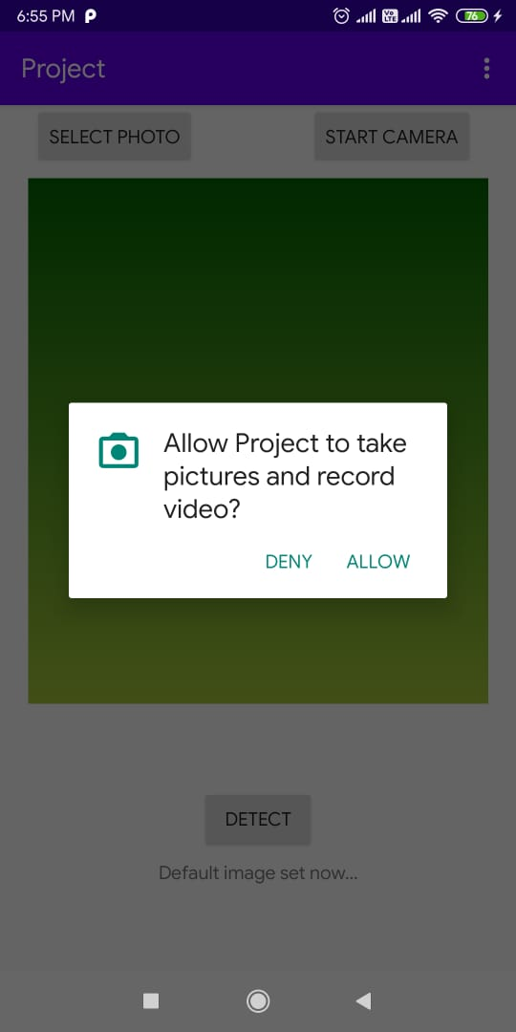

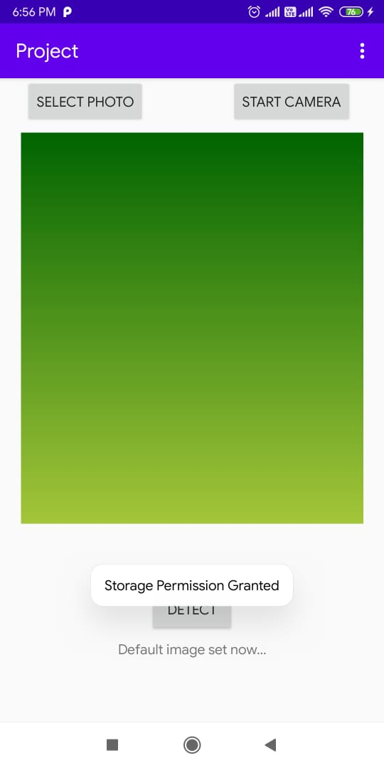

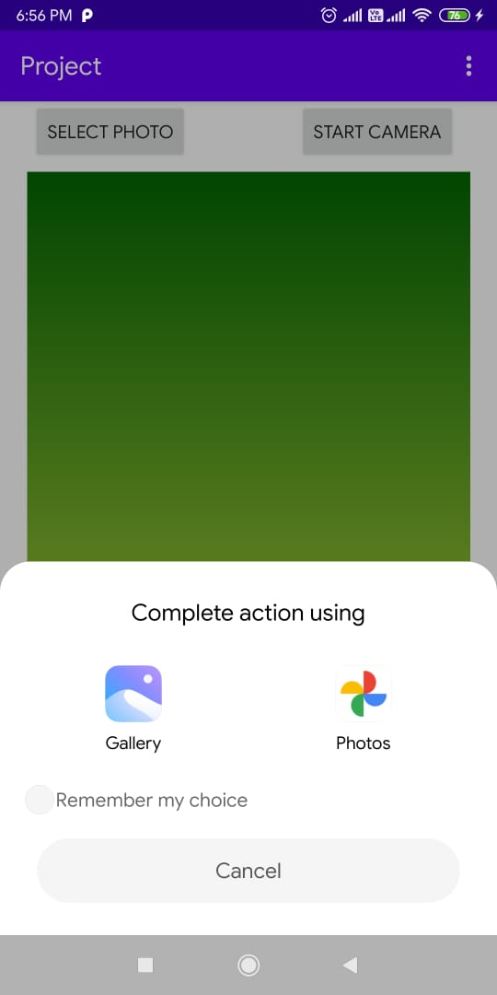

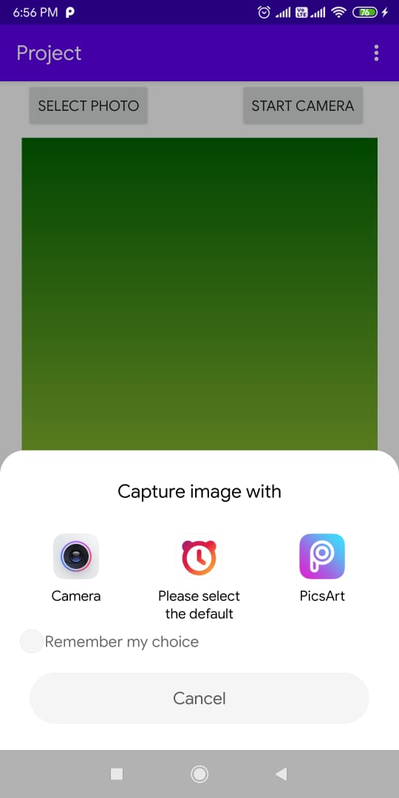

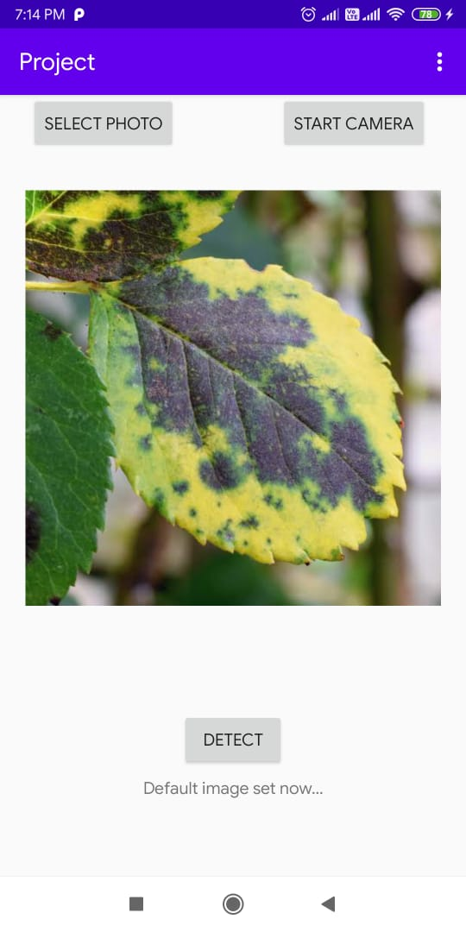

* **Work Done (28/09/2020) :**

**Completed First module**

1. **Image Scan:** On clicking the start camera button it gives an option to capture image via camera (various apps that use camera to click pictures)
2. **Image Upload:** On clicking the select photo button it gives an option to choose from gallery or Google photos.
3. **Image Displayed:** The image Scanned or uploaded is displayed in the image view.

* **Work Done (05/10/2020) :**

**Working on Training of dataset (done 30%)**

**Improved the UI.**

* **Work Done (12/10/2020):**

**Training of model (70% done)**

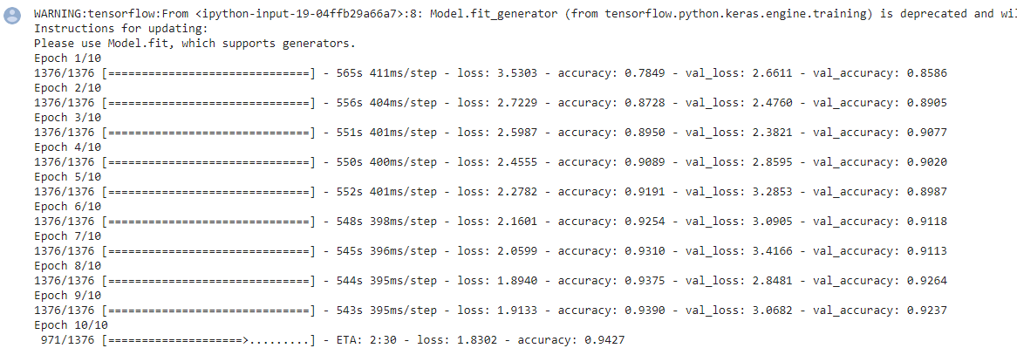

* **Work Done (26/10/2020):**

**Training of model completed**

* **Work Done(02/10/2020):**

Optimising the model.

Converted model to tflite.

Changes done in UI.

* **Work Done(09/11/2020)**

Testing the model.

* **Work Done(21/11/2020)**

Model successfully integrated with model, working on disease detail.

* **Work Done (25/11/2020)**

Project Completed.